Scrum - Rituals Workbook

Iterative Time-box Activities
Analyze
Design
Construct
Integrate
Test

Quality of an Iteration
Determined based off of different factors like the ability to deliver value, the efficiency of the process, and the effectiveness of the team’s collaboration

Quality of Outcome Determination
Determined by the effectiveness of the time boxed iterations.

Sprint definition

Known as the heart of scrum, typically a fixed period of time in which a team will commit to delivering a set of features/improvements.

Determination of length of sprint.

One month or less/2-4 weeks, but determined based on a team’s belief of what would work best to enhance team productivity.

Sprint Rituals
Sprint Planning Meeting | Consists of the initial inputs of Sprint planning including what is the Definition of Done, the Product Backlog, Retrospective commitments, and the Dev team. During the meeting, a sprint goal is established along with a plan for the delivery that needs to get done. In the end, the Spring Goal, Sprint Forecast, and Sprint Backlog are finalized.
Estimation | The act of determining (guessing) the expected size of something.  In Scrum, estimating helps to set expectations as to the amount of work that can be performed or the length of time until something is finished.

3 types of estimation When this occurs Unit of measure
Portfolio Backlog | Portfolio Planning | T-shirt sizes
Product Backlog | Product Backlog Grooming | Story points / ideal days
Sprint Backlog Tasks | Sprint Planning | Ideal hours / effort hours

Scrum Roles Involved in Estimation

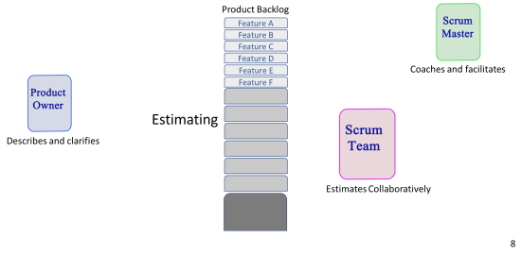Planning Poker Triangulation

Ideal day / Ideal hour

Ideal hour: Focus on the task; no interruptions
Ideal day: Constantly able to focus; No interruptions
Problems with Ideal estimation

There can’t be any interruptions as the team as to maintain full focus on the tasks

Daily Standup
Purpose

Meant to address the general progression of a sprint/what work is getting done and to address any blockers
3 Questions

What have you do since the last meeting?

What are you planning to do before the next meeting?

Do you experience any obstacles?

Rules
Must be within 15 minutes, should occur at the same time and place to make a routine, people should be standing during the meeting, and to address the 3 main questions.
Adapt the plan for the next 24 hours to ensure that we move
forward toward a successful increment.

Pair Programming

Collective code ownership!
All team members understand the code.

Two team members; one task.
Driver and navigator.

Constant reflection (real-time reviewing).

Reduction of noise.

Sprint Review Meeting
Purpose

Meant to talk about the story of the journey and give feedback, demo meeting and informal
Participants

The scrum team, stakeholders are invited, the product owner and the scrum master.
Timing

4 hours max
Location

Typically a meeting space within the organization - might be the same place as other meetings
Expected Outcomes

Meant for feedback, and collaboration. Talk about story

Sprint Retrospective Meeting
Last activity in sprint
3 hours max
Reflect on sprint
Improvements of process for future

Review the “Definition of Done”

Ritual Timing
Sprint Duration | 1 month
Daily Stand-up | 15 minutes
Spring Planning | 8 hours
Spring Review | 4 hours
Sprint Retrospective | 3 hours

